RE: TCI cost per family
DATE : 11/12/20 David T. Stevenson, Director

This is intended as a reference document for the coalition opposing the Transportation Climate Initiative along with a companion spreadsheet. The Georgetown Climate Center held a Webinar Sept. 16, 2020, that is the basis for these calculations.

TCI estimates the cost of future carbon dioxide emission allowances
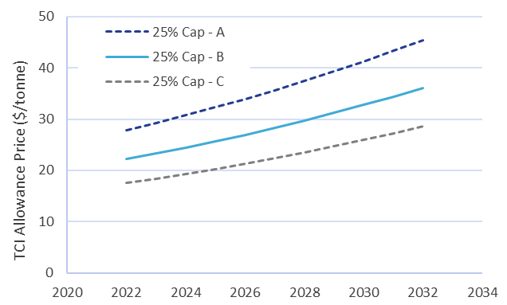

(https://www.transportationandclimate.org/sites/default/files/Fall%202020%20modeling%20webinar%2C%20final%20as%20shown%20on%2020200916.pdf page 59)

To convert cost per ton of allowance to dollars per gallon divide allowance price by 2204.6 pounds /metric ton, then multiply by 19.6 CO₂ pounds/gallon of gasoline. So, an allowance cost of $22/ton in 2022 converts to 19.6 cents per gallon ($22/2204.6X19.6). By 2032 the TCI allowance price estimate ranges from $29 to $46 with a primary estimate of $36. That translates to an estimated cost per gallon increase of 32 cents/gal. with a range of 26 to 41 cents/gal.

One spreadsheet looks at driving miles per family by year by state divided by the current average light duty fleet average miles per gallon of 22.3 miles/gal. The other spreadsheet looks at forecasted tons saved by year by TCI and expected tax revenue.

The result is an average family cost per year across the region over the eleven year forecast period of $254 with a state to state range of $200 to $310. The total cost per family over the eleven year period is $2,795. The worst case allowance cost in 2032 is $46/metric ton results in a $450/year average cost per family.

