September 19, 2018
Commissioner James P. Redeker
Department of Transportation
2800 Berlin Turnpike
P.O. Box 317546
Newington, CT 06131-7546

Dear Commissioner Redeker,
I have received your response to my FOIA request regarding the data you relied upon when making a statement in front of the Bond Commission hearing on July 25, 2018. Please be advised that your refusal to release the data that you were familiar with and so confident about that you relied upon it when making an authoritative public statement during a pivotal moment in debate about a Toll Study is unacceptable.
It is nearly 2 months after you made your statement to the Commission. If you had the data at the time to make such an unequivocal representation to the Commission the public has a right to know what that data was. In your response to my request you mention "enhanced" computer models that included "significant refinements from earlier reports". Obviously you viewed the data based on those models and had access to that data and you discussed the data with consultants. Please provide that data without delay to my office as requested in my original FOIA letter dated September and as required by Connecticut law. The exemption you claim under Connecticut FOIA does not apply since your remarks were not qualified as "preliminary" in nature. Moreover, as a vice chair of the Transportation Committee I have a right to view any information you relied upon when making a definitive public statement during debate about the toll issue.
Your prompt response as required by law is expected.
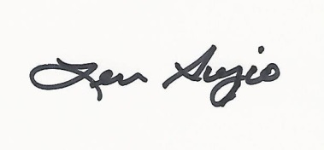
Senator Len Suzio

